Intelli-Trading Fours: Final Report

Abstract
**************************************

Introduction

1.1 Motivation
The motivation for Intelli-Trading Fours (IT4s) takes inspiration from an improvisational practice in Jazz known as “trading-fours” where musicians alternate short improvised phrases in an exchange with each other. This format enforces a cycle in which listening, interpretation and response are all derivative of each other, introducing an element of conversation to musical expression.

This interaction model demands close collaboration and near-instant responsive creativity as performers. Its success is predicated on the performers’ mutual ability to contextually interpret incoming musical material and generate a musically coherent reply within a constrained time window. Interdisciplinary research suggests that interactive improvisation engages distinct cognitive and neural processes, affirming this project’s emphasis on mutual responsiveness and temporal alignment in music dialogue (Donnay et al., 2014).

From a computational perspective, IT4s provides a framework for human-AI interaction that is both practical and structured. Performances are segmented into explicit turns comprising input capture, analysis, decision-making and response generation. This allows the system to distinguish and interpret each phase through specialised, extensible subsystems. This separation also reduces the ambiguity associated with continuous co-improvisation (Assayag, Bloch and Cont, 2006), instead providing a closed-loop interaction architecture where the system repeatedly listens, processes, responds and re-enters a waiting state.

This model forms the foundation of the system design: the implementation formalises interaction as a sequence of alternating human and AI turns, positioning the system as an interpretable collaborator operating in real time rather than as a passive offline generator. Rather than treating generation as an isolated musical artefact, IT4s situates each response within a repeated temporal exchange, reflecting accounts of computer music that emphasise musical structure as emerging across interacting temporal levels (Vaggione, 1993) and interactive systems that foreground performer-conditioned response (Pachet, 2002; Pasquier et al., 2016).

This work therefore investigates not only how an AI system can generate rhythmic material, but more pertinently, how it can meaningfully participate within a structured, time-sensitive interaction loop that mirrors human musical dialogue.

Figure 1.1: Trading-fours-inspired interaction cycle used by Intelli-Trading Fours. The system alternates between listening to a human rhythmic turn, analysing and planning a response, playing an AI response, and returning to a ready state for the next exchange.

1.2 Research Problem
Designing an interactive musical system capable of participating in real-time rhythmic improvisation presents a multi-stage technical challenge. Real-time systems must sustain a state of temporal coupling with performer input. Unlike offline or non-interactive generative approaches, these systems must: capture live musical events, derive an interpretable representation from them, generate response decisions and produce the audible output before returning to a ready state quickly enough for the exchange to remain musically coherent.

A central difficulty is that raw performance input is not immediately suitable for musical reasoning. Hit events or audio signals must be transformed into a symbolic representation that preserves timing, intensity, and phrase boundaries while remaining tractable for computation. Prior work in rhythm perception and computational music analysis shows that rhythmic interpretation is not simply a matter of counting events; meter, grouping, timing, and salience all shape how rhythmic material is understood (Longuet-Higgins and Lee, 1984; Temperley, 2009; Levitin et al., 2018).

Raw performance is not immediately suitable for musical reasoning within an Human Computer Interaction (HCI) like it might be between two human performers; this forms a central difficulty for the system. Hit events or audio signals need transforming into a symbolic representation that preserves musical properties such as timing, intensity, and phrase boundaries whilst remaining tractable for computation. Research into both computational music analysis and rhythm perception show rhythmic interpretation to be more than a binary matter of counting events; properties such timing, salience, meter and grouping all contribute to the way rhythmic material is construed (Longuet-Higgins and Lee, 1984; Temperley, 2009; Levitin et al., 2018).

This aforementioned representation subsequently informs response decisions. In the case of Intelli-Trading Fours, this necessitates an interpretable planning stage where response behaviour is variably influenced by analysed features in a controllable manner. Within this approach lies emphasis on ensuring the relationship between human input and system response observable and musically justifiable; thus distinguishing this approach from others that solely prioritise autonomous or opaque generation when considering the production of rhythmic material (Pachet, 2002; Pasquier et al., 2016; Smith, 2022).

Finally, this interaction must be sustained across repeated cycles. After musically responding, the system needs to be poised for the next human turn without accumulating stale state or losing synchronisation. Therefore positioning this project as a response to the following problem:

How can a closed-loop, real-time system capture and represent human rhythmic input, analyse it, plan an interpretable response, realise an audible output, and sustain this process across repeated turn-taking cycles?

Intelli-Trading Fours addresses this problem through the implementation of a closed-loop rhythmic interaction pipeline spanning Bela input capture across OSC with Unity-based turn orchestration, symbolic rhythmic analysis, response planning, interim response realisation, ChucK/Chunity playback, and loop closure.

1.3 Aims and Research Questions
The aim of this report is to design, implement and evaluate a closed-loop prototype for turn-based human-AI rhythmic interaction. Intelli-Trading Fours focuses on the real-time capture of human rhythmic input, its conversion into a symbolic representation, the extraction of interpretable rhythmic features, response planning, audible playback, and loop closure across repeated interaction cycles. The project does not aim to deliver a fully completed autonomous drumming agent; rather, it investigates the technical architecture required for a system to participate meaningfully in a structured rhythmic exchange.

To support this aim, the project has the following objectives:
- To implement a real-time input pipeline capable of capturing human rhythmic performance through embedded hardware and OSC communication.
- To transform captured hit events into a symbolic rhythmic representation suitable for analysis, planning, and playback.
- To design rhythmic analysis modules that extract musically relevant features such as density, energy, salient anchors, end activity, and segment-level activity profiles.
- To implement an interpretable response-planning stage in which analysed rhythmic features influence response behaviour in a controllable and observable manner.
- To integrate interim response realisation and ChucK/Chunity playback within a closed-loop turn-taking architecture that can return to a ready state after an AI response.
- To evaluate the implemented system through tests, diagnostic tools, and Unity runtime observability, while identifying the limitations of the current response-generation layer.

The dissertation is therefore guided by the following research questions:

- RQ1: How can a real-time system structure repeated turn-based rhythmic interaction between a human drummer and an AI agent?
- RQ2: How can human rhythmic input be represented and analysed in a form suitable for response planning?
- RQ3: How can interpretable planning connect analysed rhythmic features to musically justifiable response behaviour?
- RQ4: What are the technical limitations of closing the interaction loop using an interim transformation-based response layer?

These questions reflect the implemented scope of Intelli-Trading Fours. They focus the dissertation on real-time interaction architecture, rhythmic representation, analysis, planning, and loop closure, while leaving the completion of a richer generative response-realisation pipeline as a defined area for future work.

1.4 Implemented Scope and Deferred Scope
Intelli-Trading fours is implemented as a closed-loop prototype for turn-based human-AI rhythmic interaction whose system architecture supports its titular full interaction cycle. The exchange required for a Trading Fours style cycle: human input capture, symbolic rhythmic representation compilation, analysis that informs response planning, audible AI response played back and finally a return to a state ready for human input capture again. This establishes the project as an interactive real-time system rather than a collection of disconnected generation components.

The is a core infrastructure necessary to support this interaction loop is enabled through the following layers:
- Input
- Representation
- Analysis & Planning
- Output
- Observability
These infrastructural components form the technical foundation of the system and are the primary focus of the dissertation.

The response-generation pipeline is deliberately limited in scope. Whilst the system implements an interpretable response-planning layer and a prototype structural generation layer with planning logic and skeleton-oriented response design, the final response realisation stage, in which planned intent and structural skeletons are interpreted and converted into a fully developed rhythmic response, remains incomplete. In the current scope, audible AI responses are produced using an interim transformation-based mechanism. This design prioritises evaluable decision-making over expressive synthesis, leaving richer generative response realisation as a defined area for future work.

This distinction is central to this report. The project should be understood as a closed-loop rhythmic interaction prototype whose main contribution lies in the architecture, representation, analysis, planning, playback integration and observability required to support repeated human-AI rhythmic exchange. The partial state of the final generation layer is treated as an implementation limitation and future development path, rather than as a central measure of the system’s success.

A scope summary is shown in Table 1.1.

Area | Status | Role in Dissertation
Skeleton-oriented structural generation | Prototype | Prototype architecture
Audible response generation | Interim implementation | Limitation-aware implementation
Turn-taking orchestration | Implemented | Core system architecture
Bela/OSC input capture + Hit buffering and turn capture | Implemented | Implementation chapter
Quantisation into PatternTurn | Implemented | Implementation chapter
Rhythmic analysis modules | Implemented | Core technical contribution
Response planning | Implemented | Core technical contribution
ChucK/Chunity playback | Implemented | Implementation chapter
Loop closure after playback | Implemented | Closed-loop architecture contribution
Debugging, observability tools, Automated tests and diagnostics | Implemented | Evaluation/supporting infrastructure
User evaluation with drummers | Deferred | Evaluation limitation / future work
Full response realisation from plan/skeleton | Deferred | Future work
Long-term musical memory | Deferred | Future work

1.5 Contributions
A summary of the main contributions is shown in Table 1.2.

Contribution | Realisation (System Components) | Significance
Closed-loop turn-taking interaction model | TurnLoopController, TurnPhase, loop closure logic | Formalises real-time human-AI rhythmic exchange as an iterative, state-driven interaction system
Real-time sensor-to-symbolic capture pipeline | Bela input, OSC messaging, OscHitReceiver, HitBuffer | Enables low-latency transformation of physical performance into analysable rhythmic data
Hybrid symbolic-temporal rhythm representation | TurnWindow, PatternCompiler, PatternTurn | Captures both quantised structure and expressive timing, supporting meaningful musical analysis
Feature-driven rhythmic analysis framework | Density, energy, anchor, end-activity, segment profile analysers | Provides interpretable, multi-dimensional characterisation of rhythmic input
Deterministic response planning model | ResponsePlanner, ResponsePlan, response-type system | Enables explainable mapping from musical features to structured response strategies
Structured response generation pipeline | SkeletonBuilder, map builders, generation pipeline stages | Decomposes rhythm generation into controllable stages, enabling variation and constraint-driven synthesis
Integrated real-time playback system | IT4ChuckTurnPlayer, ChucK/Chunity scripts | Closes the interaction loop through synchronised audio response
System observability and debugging framework | Debug presenters, visualisation panels | Supports interpretability, development, and evaluation of system behaviour

Background & Related Work

2.1 Musical Metacreation and Machine Musicianship
The term Musical Metacreation (Pasquier et al. 2016) provides the broad research context describing systems that use computation to participate in musical tasks such as composition, performance, improvisation and accompaniment. However, machine creativity within this field is not uniformly defined. Some systems frame creativity as the autonomous production of musical artefacts, while others understand it as an interactive process shaped by human input, shared agency and real-time response.

This section reviews the literature across three conceptual axes: autonomous generation versus co-creative interaction, machine output versus human-machine process and independent musical authorship versus responsive machine musicianship. This framing is important for conceptualising the essence of creativity within IT4s.

2.1.1 Musical Metacreation As A Field
Musical metacreation, often abbreviated as MuMe, describes computational systems that take on creative musical tasks. The definition’s breadth is useful for situating Intelli-Trading Fours but requires a more precise classification of the project’s contribution. Rather than treating all AI music systems as a homogenous category, the following discussion distinguishes between systems that generate musical material independently and systems whose creative behaviour is contingent on live human interaction.

For IT4s, the usefulness of MuMe is not that it legitimises any computational music system as “creative”, but that it provides a vocabulary for locating different forms of machine musical agency. The project sits inside this field because it delegates parts of musical interaction to software: listening, representation, analysis, planning and playback. However, its contribution is narrower than autonomous musical authorship. The system’s musical behaviour depends on a human rhythmic turn and is therefore better understood as interactive machine musicianship.

2.1.2 Autonomous Generative Agents
One strand of musical metacreation frames machine creativity primarily through autonomous generation. In such systems, creative behaviour emerges from processes that are largely self-contained within the computational domain through learned models, internal rules or agent based interaction with other software entities.

Eigenfeldt’s Musebots exemplify this approach, demonstrating musical collaboration between autonomous agents whose creative agency remains largely within the computational system without strict temporal dependency on external input rather than being negotiated in an exchange with a live performer (Eigenfeldt, 2013). While this model is useful for understanding machine autonomy, it differs from the interactional problem addressed in this work, where responses must be derived from temporally bounded human input.

2.1.3 Interactive And Co-Creative Machine Musicianship
A contrasting perspective frames creativity not solely within autonomous generation, but within the interaction between a computational system and a human performer. In this model, the machine’s musical behaviour is informed by what the performer has just played, positioning the system’s contribution as a response, continuation, transformation or accompaniment rather than as an isolated artefact.

Pachet’s Continuator is a significant example of this performer-conditioned approach. The system learns from a musician’s input and generates stylistically related continuations in real time, bridging autonomous generation with interactive musical performance (Pachet, 2002). Its relevance lies less in its specific modelling method, instead framing machine musicianship as contextually responsive participation.

The Continuator demonstrates that a computational system can derive musical material from a performer’s contribution and return output that is meaningful within an ongoing exchange, however, Intelli-Trading Fours takes a different design route. Rather than pursuing style-learning continuation, its architecture is explicitly segmented. This results in a system more limited as a generative model, but more transparent and interpretable as an interaction architecture.

2.1.4 Product-Centred Versus Process-Centred Creativity
The distinction between autonomous and interactive systems also affects how creativity should be evaluated. Product-centred approaches focus on the quality of the generated musical artefact, which is appropriate for systems that produce self-contained compositions or standalone musical outputs. However, interactive music systems require a more process-centred view. Their creative value cannot be judged only by the standalone quality of generated material when it also depends on how the system participates in the unfolding exchange with a performer.

Smith’s account of human-AI musical partnerships frames agency, control and collaboration as interactional concerns, while Ostermann et al.’s evaluation of reactive jazz accompaniment demonstrates that perceived creativity and musical usefulness can be assessed through the user’s experience of real-time system behaviour rather than through output alone (Smith, 2022; Ostermann et al., [year]).

This is particularly relevant to Intelli-Trading Fours, where the central contribution lies not in claiming a finished autonomous generative model, but in an observable and inspectable closed-loop pipeline.

2.2 Human-AI Improvisation and Co-Creative Systems
Having positioned Intelli-Trading Fours as a form of interactive machine musicianship, this section considers what makes human-AI musical interaction meaningful in practice. In improvisational contexts, the system’s value does not depend only on the material it generates, but on how it listens, responds, shares agency and sustains the performer’s sense of an unfolding musical exchange.

2.2.1 Improvisation As Perception And Response
A central problem in human-AI improvisation is that the system must treat performer input as musical context rather than as arbitrary data. Thom’s work on real-time interactive improvisation is useful here because it frames improvisational companionship as a time-sensitive problem of perception and response, where the system must interpret live musical material quickly enough to produce an appropriate continuation or accompaniment (Thom, 2000). Similarly, Pachet’s Continuator demonstrates how performer input can become the basis for real-time musical continuation, showing that machine-generated material can function as part of a live exchange rather than as a detached composition (Pachet, 2002). Together, these systems frame improvisation as a perception-response loop in which listening and generation are mutually dependent rather than separate stages.

Intelli-Trading Fours adopts this perception-response principle, but narrows it to a turn-based rhythmic setting. This differs from systems that attempt continuous accompaniment or stylistic continuation across an open-ended performance. The specific musical basis for this turn-taking model is developed further in Section 2.5.

2.3 Reactive, Predictive and Generative Musical Agents
The previous section established human-AI improvisation as an interaction loop in which perception, timing and agency shape the musical exchange. This raises a further question: what is the nature of this interaction? Interactive music systems can be positioned along a spectrum from reactive systems, which respond directly to current input; to predictive systems, which model likely future behaviour; and generative systems, which produce more independent or stylistically developed musical material. This distinction is not hierarchical, but reflects different approaches to modelling interaction, agency, and musical structure.

2.3.1 Reactive Musical Interaction
Reactive musical systems respond to performer input, environmental events or changing musical state. Petit and Serrano’s work on reactive programming for interactive structured music is helpful here for presenting how musical systems can combine deterministic structure with live or nondeterministic interaction through explicit states, events and patterns (Petit and Serrano, [year]). This supports the view that real-time musical responsiveness often depends on architecture as much as on generation.

Systems adopting this approach often structure behaviour around externally conditioned responses, where output is derived from recent or current input rather than from an independent generative process. Such systems may still incorporate structured decision-making and internal constraints, but their defining behaviour is anchored in the interaction context.

2.3.2 Predictive Interactive Systems
Predictive musical systems extend this idea by modelling likely future behaviour. Martin and Torresen’s Interactive Musical Prediction System, for example, uses mixture density recurrent neural networks to predict future user control data in real time (Martin and Torresen, 2019). Such systems can support powerful forms of musical assistance and co-performance but they also introduce different trade-offs around training data, opacity, evaluation and control.

2.3.3 Generative Response And Drum-Performance Models
Generative musical agents prioritise the production of novel musical material, often using learned models or rule-based systems to construct patterns that extend beyond direct transformation of input.

Pachet’s Continuator remains relevant here as it combines interaction with stylistically informed continuation (Pachet, 2002). More recent learning-based work also frames musical response generation as a data-driven problem. Hu et al., for example, approach call-and-response as automatic composition using a knowledge-enhanced model, while Gillick et al. demonstrate learned drum-performance generation and humanisation through sequence transformation (Hu et al., [year]; Gillick et al., 2019). These systems are useful comparison points because they demonstrate response generation beyond simple transformation or rule-based planning.

2.3.4 Positioning Intelli-Trading Fours
The distinction between reactive, predictive and generative agents is therefore not a hierarchy in which reactive systems are automatically weaker. Vaggione’s critique of simple deterministic-versus-random framings is useful here because it suggests that musical structure can emerge through constraints operating across different temporal levels rather than through unconstrained generation alone (Vaggione, 1993).

Intelli-Trading Fours is best understood as a reactive, planning-led, turn-based musical agent with partial generative structure. Its behaviour is conditioned on recent human input, mediated through interpretable analysis and planning stages. Compared with predictive and fully generative systems, this approach prioritises transparency, controllability, and architectural clarity over expressive autonomy.

This partial generative structure reflects the core contribution of the work: not autonomous musical creativity, but the design of a structured and interpretable interaction system.

2.4 Rhythm, Timing, Entrainment, and Turn-Taking
It is important to note that the interaction problem is specifically rhythmic. Rhythm is not simply musical content that can be generated after the fact; it is a temporal medium through which performers coordinate action, perceive structure and experience responsiveness (Longuet-Higgins and Lee, 1984). This makes timing a central design concern for IT4s as responses must be situated appropriately within a shared temporal framework.

2.4.1 Rhythm As A Time-Sensitive Interaction Medium
In musical interaction, rhythmic information is not experienced solely as an abstract pattern; it is felt through the timing of events with respect to the performer’s expectation of when future events should occur. This is especially important in percussion-based interaction, where pitch and harmony do not contribute to its evaluation as much as musical properties such as: onset timing, density, accent and dynamic energy.

This requires positioning rhythm as both data and interaction. The system should not merely need to detect that a drum hit happened; it needs to know where that hit occurred within a temporal frame. Timing is therefore not a secondary implementation detail, but a central musical concept that the system must prioritise.

2.4.2 Machine Listening And Rhythmic Feature Extraction
Interactive rhythmic systems also require a form of machine listening. Scheirer’s work on music-listening systems becomes relevant here because its framing of computational listening as the extraction of musically meaningful information such as tempo, segmentation and perceptual orientation (Scheirer, 2000). Although IT4s does not attempt full audio-scene understanding, it still faces a related problem: live performance events must be transformed into features that a computational agent can use for response planning.

2.4.3 Quantisation, Expressive Timing and Symbolic Representation
A key challenge in rhythmic interaction is that performed timing is rarely perfectly aligned to a grid. Longuet-Higgins and Lee argue that rhythmic interpretation involves resolving ambiguity through assumptions about regularity, meter and grouping (Longuet-Higgins and Lee, 1984). This is relevant to IT4s whose architecture converts temporally messy live input into a representation that is stable enough for analysis and response planning. Quantisation is therefore not just a technical convenience; it is an interpretive act that decides how performed events relate to an underlying rhythmic structure.

At the same time, quantisation introduces a trade-off. A rigid grid can make analysis and generation tractable but can also flatten expressive timing. The musical importance of expressive timing in drum patterns is highlighted by Gillick et al.’s work on drum performance with regard to generation and humanisation. In particular, the research emphasises the relationship between a performed groove and an associated abstract rhythmic structure (Gillick et al., 2019). IT4s employs a clear and interpretable symbolic representation for the later planning stages, while retaining timing offset information within the representation of a compiled turn. This positions the system as suitable for analysis of a deterministic nature, while maintaining extensibility in the form of richer expressive timing and humanisation for future work.

2.4.5 Implications For Intelli-Trading Fours
The literature on rhythm, machine listening and timing supports a central design decision in IT4s, the system therefore perceives rhythm not only as musical content, but as an architectural coordination problem. Timing must be preserved, discretised, interpreted, and rescheduled across the interaction loop. While Intelli-Trading Fours does not implement continuous entrainment, the next section builds on these ideas by considering trading fours specifically, where turn-taking is not only a technical convenience but a musical practice that gives the interaction its dialogic form.

2.5 Trading Fours and Turn-Based Musical Dialogue
Trading fours serves as a useful musical model for IT4s because it contains a clear alternation between listening and response. In jazz practice, a performer does not simply produce an isolated phrase; they contribute musical material that invites a subsequent reply. Hodson and Donnay et al. use trading fours as a model of interactive improvisation and frame it as a form of musical communication involving collaborative and emergent exchange (Donnay et al., 2014; Hodson, 2007). For IT4s, this means that trading fours is not only a stylistic reference, it provides a structured interaction model in which the meaning of a response depends on its relation to the preceding turn.

This structure is not a simplification but an execution of real improvisation, giving the system a practical form of musical accountability. Each AI response is evaluated as an answer to a specific human turn, rather than as an independent generated artefact. This supports the dissertation's wider distinction between autonomous generation and responsive interaction: IT4s does not claim to be a fully open-ended improviser, but it does implement the conditions needed for repeated rhythmic dialogue. The turn boundary makes the source material identifiable, the response process inspectable and the re-entry point testable.

The limitation is that this design reduces the simultaneity of human musical interplay. IT4s does not currently negotiate tempo with the performer. Instead, it treats trading fours as a discrete call-and-response structure in which musical dialogue is mediated by state transitions. This trade-off is appropriate for the current prototype because it makes the interaction observable and technically defensible: responsiveness can be discussed in terms of capture accuracy, response timing, phase correctness and loop closure, while richer forms of overlapping improvisation remain viable future work.

2.6 Metrical Hierarchy, Salience, and Rhythmic Structure
After a structured form of rhythmic input has been achieved, the challenge becomes determining which elements of that structure are musically significant. Rhythm, more than simply a sequence of discrete events, is better described as a perceptual construct shaped by hierarchical organisation, accent, and expectation.

2.6.1 Metrical Hierarchy and Rhythmic Interpretation
Research in the human perception of rhythm demonstrates that listeners do not interpret rhythmic sequences as flat patterns of events, but as structured hierarchies organised around an underlying meter. Longuet-Higgins and Lee (1984) argue that rhythmic interpretation depends on assumptions about regularity, grouping and metrical structure, such that identical event sequences may be perceived differently depending on their inferred context.

Within this hierarchical framework, not all events contribute equally to perceived structure. Certain events become points of emphasis or structural anchors that draw attention based on their position, intensity or contextual contrast. Salience may arise from multiple factors, including dynamic accent, placement on metrically strong positions, relative isolation or proximity to phrase boundaries.

From a computational perspective, this implies the need for models that estimate the relative importance of events rather than treating all onsets uniformly. Such models typically combine heuristic indicators of salience, allowing systems to approximate which elements of a rhythmic pattern are likely to carry structural weight.

This abstraction gives way to systematic reasoning about rhythm, including the identification of recurring patterns, structural positions and relationships between events. While such representations necessarily simplify continuous performance, they provide a tractable framework for both analysis and generation, particularly in systems operating under real-time constraints.

2.6.5 Implications for Interactive Musical Systems
Taken together, these perspectives highlight that rhythmic interaction requires systems to operate on structured representations that capture both hierarchical organisation and perceptual salience. For interactive systems, this is particularly important because responses must relate meaningfully to the perceived structure of input rather than to its raw event stream.

Accordingly, effective interaction requires models that can:

- identify structurally significant events
- capture phrase-level patterns and activity contours
- operate on representations that balance interpretability with computational tractability

These requirements directly motivate the use of feature-based rhythmic analysis in interactive systems, where structural descriptors provide a bridge between raw input and higher-level response behaviour.

2.7 Evaluation of Interactive Music Systems
Given the interaction-focused framing established in earlier sections, evaluation in Intelli-Trading Fours cannot be reduced to the quality of generated output alone. Prior work suggests generative music systems do not admit a single objective ground truth, instead they are evaluated across dimensions such as coherence, variability and interactivity (Briot, Hadjeres and Pachet, 2020). This complicates the use of conventional output-based metrics, particularly in systems where musical material is produced in response to external input rather than in isolation.

This challenge is amplified in interactive contexts due to the aforementioned research by Smith (2022) and Ostermann ([year]) who argue place creative value within interaction and evaluate reactive accompaniment systems through metrics that depend on real-time behaviour and contextual alignment.

As a result, evaluation in this project is framed in terms of system behaviour within the interaction loop. Rather than treating generated rhythms as standalone artefacts, the evaluation focuses on architectural and behavioural properties aligned with the system’s design objectives. These include timing correctness, state consistency, responsiveness, interpretability and structural response behaviour. This approach ensures that evaluation reflects the system’s contribution as a closed-loop, real-time interaction architecture, rather than as a fully autonomous generative model.

System Design
The design of Intelli-Trading Fours is driven by the central research problem identified in Chapter 1: how to construct a system capable of real-time, musically meaningful interaction with a human performer. Chapter 2 discussed the existing approaches and limitations in both offline generative systems and reactive accompaniment models, particularly in their ability to sustain structured, interpretable musical exchange. This section therefore establishes the design principles that govern the system.

3.1 Design Principles and System Framing

The design of Intelli-Trading Fours is driven by the requirement to support real-time, musically meaningful interaction between a human performer and an artificial agent. Rather than treating the system as a standalone generator, it is framed as an interaction architecture in which behaviour is defined by responsiveness to performer input.

Three principles govern this design:
- real-time operation constrains all decision-making to bounded temporal windows, favouring incremental and computationally lightweight processes over long-horizon optimisation.
- interaction is structured rather than continuous, enabling clear segmentation of input and response and reducing ambiguity in timing and responsibility.
- the system prioritises interpretability, exposing intermediate representations that make its behaviour understandable and controllable.

These principles position the system as reactive rather than generative. Outputs are not produced in isolation, but are shaped by the structure of the performer’s input within each interaction cycle. To support this, the system adopts a symbolic representation of rhythm, enabling tractable reasoning over temporal structure while maintaining alignment with perceptual models of rhythmic organisation.

This framing establishes a controlled but flexible basis for human–AI musical dialogue. It prioritises responsiveness, clarity, and evaluability, while accepting trade-offs in expressive nuance, continuous interaction, and stochastic variability.

3.2 Interaction Model and Temporal Structure
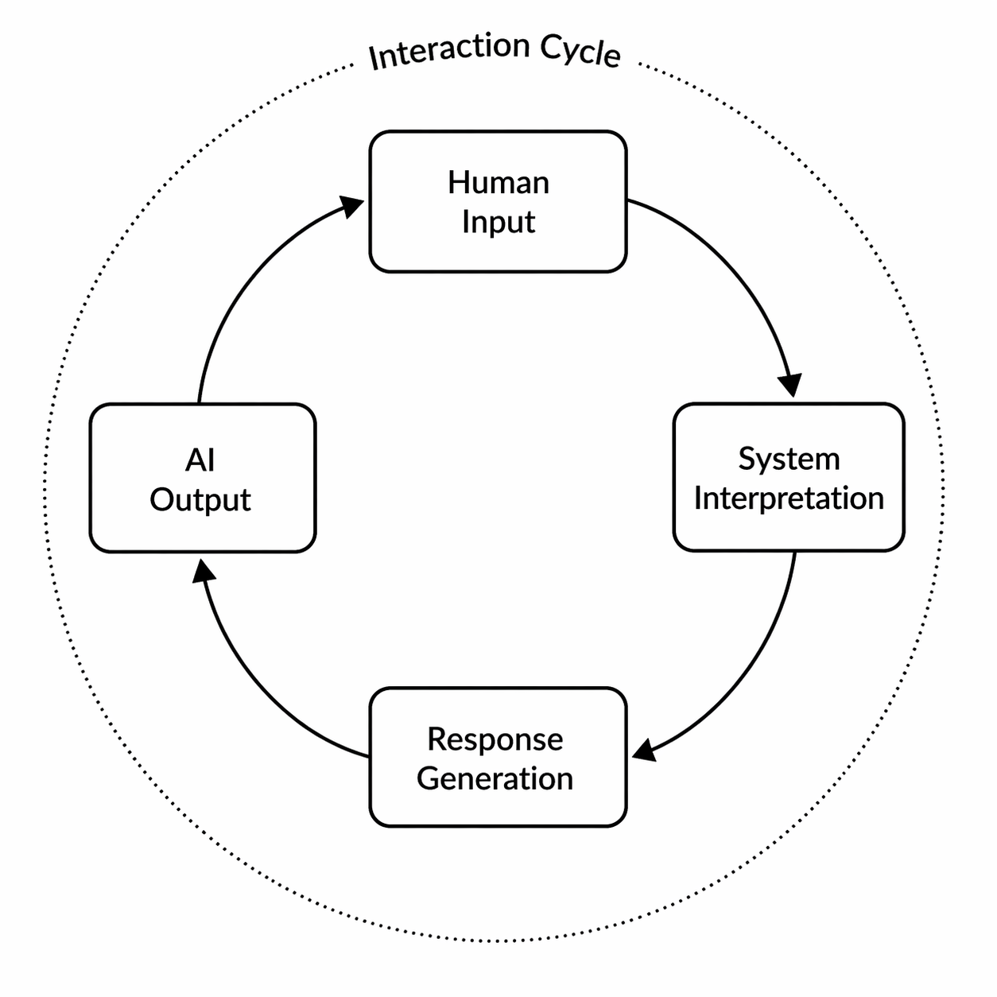
Figure X: Closed-loop interaction model illustrating the turn-based exchange between performer input and system response.

The system is structured as a turn-based interaction loop in which human input and system response occur in alternating cycles. This resolves the temporal ambiguity of continuous co-improvisation by introducing explicit boundaries for when input is interpreted and when responses are produced.

Each cycle forms a bounded interaction unit. Input is treated as a complete segment, allowing analysis and response to be performed within a finite time window. This constraint supports real-time operation by limiting the scope of computation and avoiding dependence on extended performance history.

The model emphasises responsiveness over continuity. By enforcing alternation, the system establishes a clear mapping between input and response, improving interpretability and enabling direct evaluation of system behaviour.

This design prioritises structural clarity and control, at the cost of reduced expressive fluidity compared to continuous ensemble interaction.

3.3 Symbolic Representation Strategy

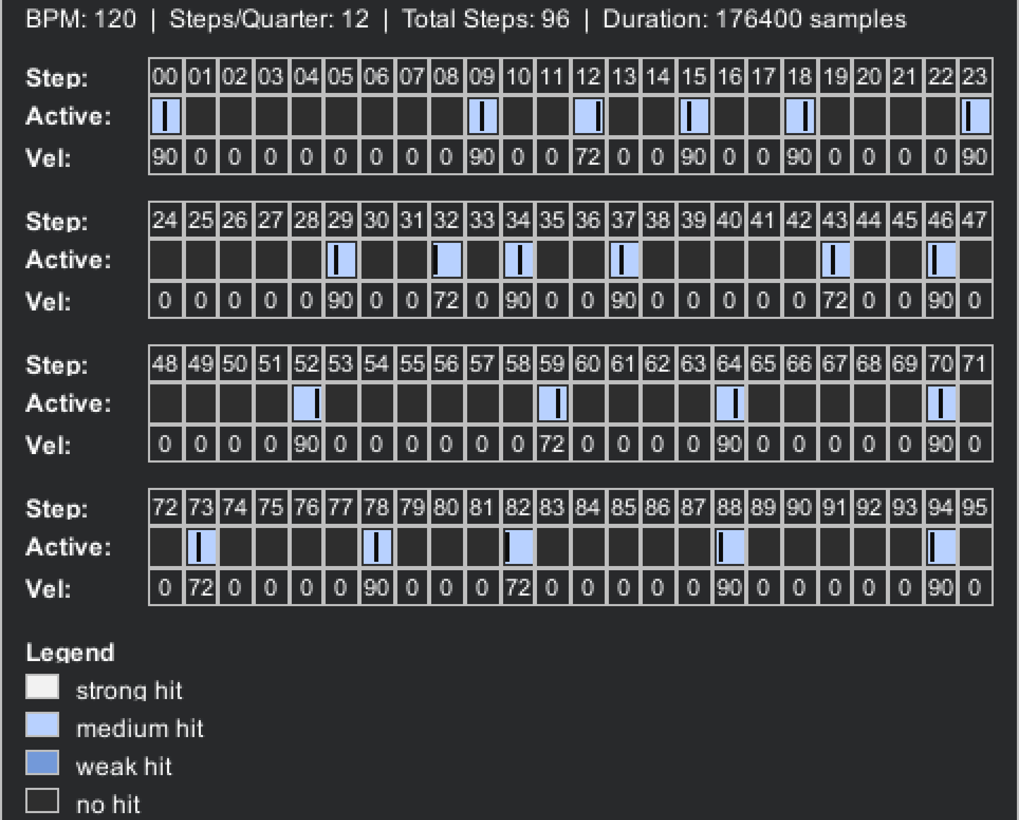

The system represents performance using a symbolic, time-structured abstraction rather than raw audio. Continuous input is mapped onto a discrete temporal grid, allowing rhythmic events to be interpreted in terms of relative timing, intensity, and position within a structured cycle.

This abstraction enables the system to reason about musical structure. By imposing a consistent temporal framework, ambiguity in timing is reduced and patterns such as density, emphasis, and phrasing become computationally accessible. This aligns with perceptual accounts of rhythm, where listeners organise events according to metrical and grouping structures.

The choice of symbolic representation prioritises tractability and interpretability. It allows downstream processes to operate deterministically on structured data, rather than relying on complex signal-level analysis.

This design trades expressive nuance for clarity. Fine-grained timing variation and timbral detail are simplified, but the resulting representation supports consistent analysis and controllable response generation.

3.4 Interpretable Analysis and Planning
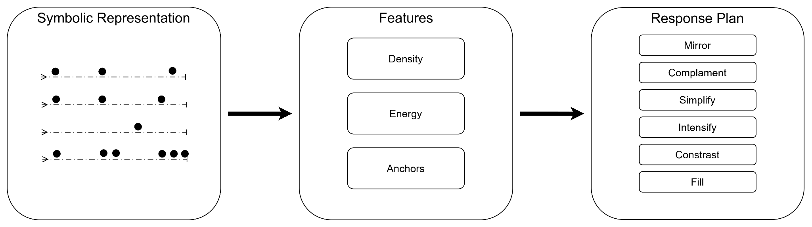

The system derives meaning from input through a structured analysis and planning process. Rather than directly transforming input into output, it first extracts a set of interpretable descriptors capturing aspects of rhythmic structure, such as activity, emphasis, and distribution over time.

These descriptors form the basis of a decision layer that determines how the system should respond. Instead of producing output through opaque or end-to-end methods, the system explicitly maps analysed input characteristics to a small set of response behaviours, defining the intended relationship between input and output.

This separation between analysis and planning supports interpretability. Because decisions are expressed in terms of observable features and discrete response types, system behaviour can be inspected, understood, and evaluated. This is particularly important in interactive settings, where responsiveness must be both perceptible and explainable.

The design prioritises transparency and control over expressive complexity. While this limits the richness of possible responses compared to more implicit models, it ensures that responses remain meaningfully grounded in the structure of the performer’s input.

3.5 Structural Response Generation and Output Coupling

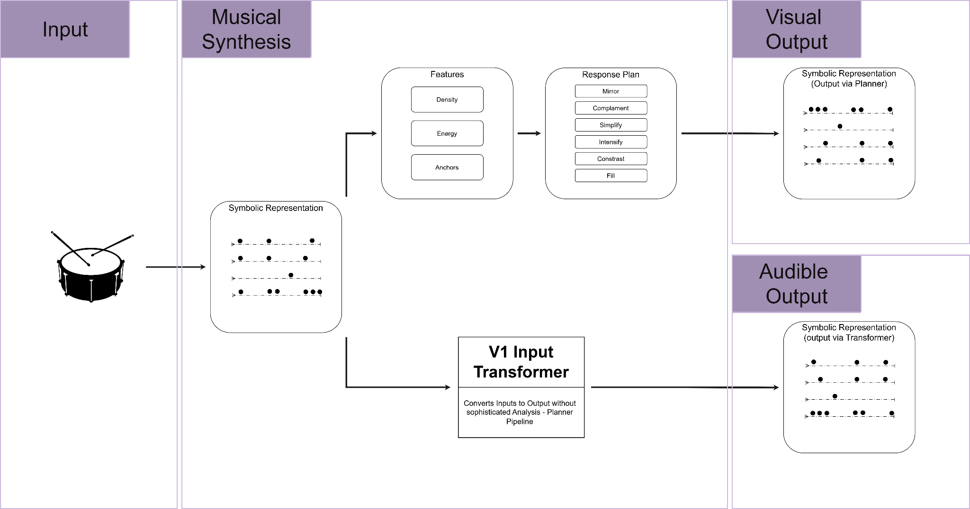
The system models response generation as a two-stage process: first determining how to respond, and then determining how that response is realised. This distinction allows interaction to be defined in terms of interpretable musical intent, rather than direct transformation of input patterns.

As shown in Figure X, the intended design follows a reasoning pathway from input analysis to response planning, and from planning to a structured rhythmic pattern. Within this framework, the system selects a response strategy (e.g. mirroring, contrasting, extending) based on extracted features, and expresses this intent structurally by shaping the distribution of events across the rhythmic grid. This establishes a clear separation between decision-making and pattern construction, supporting transparency and controllability in the interaction process.

However, the current output pathway diverges from this intended design. Audible responses are not generated from the structural pattern, but instead through a transformation process applied directly to the input representation. As illustrated in the diagram, this results in a partial coupling between structural reasoning and realised output.

This boundary is a defining characteristic of the current system. While the architecture successfully implements an interpretable reasoning framework, the translation from planned structure to audible behaviour is not yet fully integrated. Consequently, the system’s internal decision-making is more developed than its external musical realisation.

This design reflects a deliberate prioritisation of interpretability and structural clarity over immediate expressive completeness.

Evaluation

5.1 Evaluation Framework and Scope
The role of this chapter is to evaluate Intelli-Trading Fours not as a finished autonomous musical performer but as a technical interaction system. As previously established, the implemented contribution is a closed-loop prototype for turn-based human-AI rhythmic exchange, encompassing: input capture, symbolic representation, rhythmic analysis, response planning, playback, and return to a ready state for repeated interaction. The purpose of this evaluation is therefore not to assess artistic quality in isolation, but to determine whether the system behaves as intended according to the design decisions established in Chapter 3.

Accordingly, the chapter adopts an evidence-driven, architecture-level evaluation framework where the system is assessed through a combination of:
- subsystem tests
- batch diagnostic outputs
- runtime observability tools
- structural analysis metrics

Subsystem correctness is validated through unit and integration testing at each state phase. Higher-level behaviour is examined using large-scale batch output data (e.g. statistical distributions, structural divergence measures), curated case studies and controlled input-variation experiments. Runtime debug interfaces also provide direct observability into internal system states, facilitating interpretability past relying solely on output inspection.

To operationalise this framework, evaluation is organised around the following core questions:

- Does the system demonstrate stable closed-loop interaction across repeated turns?
- Are response planning decisions interpretable and internally consistent?
- Do different response types produce structurally distinct rhythmic outputs?
- Does the system exhibit reactivity, such that variations in input lead to meaningful variations in response?
- Does the system operate within real-time constraints, particularly in post-capture latency?
- To what extent is planner intent preserved in the generated output, and where does this break down?

Evaluation Question | Claim Type | Evidence Source(s) | Method of Analysis | Output (Figure/Table)
Does the system demonstrate stable closed-loop interaction? | Strong | Integration tests, TurnLoopController execution, runtime logs | End-to-end execution validation, phase consistency checks | System flow diagram, execution trace (Fig. 5.x)
Are planning decisions interpretable and internally consistent? | Strong | Planner CSV (300 runs), planner debug output | Distribution analysis, margin analysis, rule consistency inspection | Planner distribution (Fig. 5.1), margin plot (Fig. 5.2)
Do response types produce structurally distinct outputs? | Strong | Skeleton batch outputs (1800 cases), structural metrics | Overlap, divergence, anchor preservation, gap-fill analysis | Structural metrics table (Table 5.4), divergence plot (Fig. 5.5)
Does the system exhibit reactivity to input variation? | Partial | Variant dataset (input perturbations), planner outputs | Sensitivity analysis (response type changes vs input changes) | Variant sensitivity table/plot (Fig. 5.x)
Does the system operate within real-time constraints? | Partial | Timing logs (capture → playback), runtime profiling | Latency measurement (post-capture delay, stage timings) | Latency plot (Fig. 5.9)
Is planner intent preserved in generated output? | Partial | Curated cases, plan vs output dataset | Structural comparison (density, overlap, pattern alignment) | Plan vs output comparison (Fig. 5.8), case table (Table 5.3)
Is the system musically plausible as an interaction partner? | Partial | Curated outputs, qualitative inspection | Case-based interpretation (no user study) | Annotated case figures (Fig. 5.3–5.4)
Does the system support perceptual or user-level evaluation? | Deferred | - | Not evaluated in this work | -
Does the system support long-term adaptation or learning? | Deferred | - | Not implemented | -

Each of these questions corresponds to a specific class of evidence (tests, batch data, timing logs, or curated cases) supported by figures and tables derived directly from system outputs. This ensures that evaluation claims are grounded in measurable behaviour rather than descriptive assertion.

The scope of evaluation is intentionally constrained. This chapter is not intended to establish perceptual musical quality, listener satisfaction, or the effectiveness of the system as a fully realised co-creative partner. While these aspects broadly relate to interactive music systems, they are beyond the current scope. Instead, the focus is on whether the system functions as a coherent, interpretable and responsive interaction architecture - identifying the extent to which this goal has been achieved.

This distinction is critical when interpreting results. Structural and computational evidence can demonstrate that the system is responsive, internally consistent, and capable of differentiated behaviour, but cannot alone establish artistic success. For this reason, the evaluation separates strongly evidenced claims (e.g. architectural correctness, planner interpretability, structural differentiation), partially evidenced claims (e.g. real-time responsiveness, plan-to-output fidelity, musical plausibility), and explicitly deferred claims (e.g. user evaluation, long-term adaptation, fully expressive generation).

By structuring the evaluation in this way, Chapter 5 reinforces Intelli-Trading Fours not as a completed musical system, but as a well-instrumented, technically grounded prototype, whose behaviour can be rigorously analysed, whose scope is outlined, and whose design decisions can be critically assessed within the broader context of interactive musical systems.

5.2 Implementation Validation
This section validates the correctness of the Intelli-Trading Fours system as an integrated, closed-loop interaction architecture. The aim is to establish that the system executes reliably across its full interaction cycle.

At a system level, Intelli-Trading Fours is designed as a phase-based interaction loop, consisting of sequential stages: input capture, turn segmentation, symbolic compilation, rhythmic analysis, response planning, response generation, playback and transition back to a ready state. Validation therefore focuses on confirming that each stage executes correctly in isolation, and that transitions between stages occur deterministically and without failure.

To support this, a combination of unit testing, integration testing, and runtime validation is employed.

Unit tests verify the correctness of individual subsystems, including feature extraction, response planning logic, and skeleton generation behaviour providing a baseline guarantee of correctness at the subsystem level.

Integration testing extends this validation to the full interaction loop. Controlled input sequences are passed through the system to confirm that the pipeline executes without interruption, that state transitions occur in the correct order, and that outputs are produced at the expected stages. Particular attention is given to the TurnLoopController, which orchestrates the interaction phases, ensuring that transitions such as Capturing → Compiling → Planning → Playback occur consistently and without race conditions or dead states.

In addition to formal tests, runtime observability tools are used to validate behaviour during execution. Debug interfaces provide real-time visualisation of internal representations, including captured hit events, quantised PatternTurn structures, extracted features, planner outputs, and generated response patterns. This allows verification not only that the system produces outputs, but that intermediate representations remain coherent and interpretable throughout execution. Such observability is particularly important in interactive systems, where silent failures or misalignments between stages may not be immediately apparent from output alone.

The results of this validation indicate that the system reliably completes the full interaction cycle under controlled conditions. Input events are successfully captured and segmented into discrete turns, symbolic representations are constructed consistently, analysis and planning stages execute deterministically, and response playback is triggered without failure. The system also consistently returns to a ready state following playback, enabling repeated interaction cycles without manual reset.

Overall, this section establishes that Intelli-Trading Fours satisfies its core requirement as a working closed-loop interaction system, providing a stable foundation for the behavioural and structural evaluations that follow.

Figure 5.x - Abstracted state transition trace of the interaction loop, showing the progression through capture, compilation, response generation, and playback phases. Annotations indicate key events derived from runtime logs, demonstrating deterministic execution and successful loop closure.

5.3 Planner Behaviour, Interpretability, and Reactivity
The response planner forms one of the central decision-making components of Intelli-Trading Fours, translating analysed rhythmic features into an explicit response intention. Unlike end-to-end generative systems, the planner functions as an interpretable intermediate layer, making its behaviour directly inspectable. This section evaluates the planner in terms of response diversity, decision confidence, interpretability and sensitivity to input variation.

5.3.1 Distribution of response types

A primary requirement of the planner is that it should produce a range of response types rather than collapsing to a single dominant strategy, thus exhibiting non-degenerate behaviour.

Figure 5.2 shows the distribution of selected response types across 300 analysed cases.

The results indicate that all response types are represented, with Intensify occurring most frequently (118 cases, 39.3%), followed by Fill and Mirror (62 cases each, 20.7%), Complement (36 cases, 12.0%), and Contrast (22 cases, 7.3%). This confirms that the planner generates structurally varied responses rather than defaulting to a single behaviour.

However, the distribution is not uniform. The dominance of Intensify indicates input patterns within the evaluated dataset more frequently satisfy the conditions associated with energy or density expansion. This asymmetry reflects both the planner’s scoring structure and the characteristics of the input set, revealing response selection as being shaped by underlying feature distributions rather than being arbitrarily balanced.

5.3.2 Decision margins and ambiguity
To assess the robustness of planner decisions, the distribution of decision margins was analysed (Figure 5.3). Decision confidence is represented by a margin indicating the difference between the highest-scoring response type and its nearest competitor.

The results show a wide spread of margins, ranging from near-zero to approximately 1.5. High-margin cases correspond to strong, unambiguous decisions, while low-margin cases indicate boundary conditions where multiple response types are plausible. Importantly, these boundary cases are explicitly visible rather than hidden, allowing inspection of competing responses and their associated scores.

This behaviour reflects a key design property of the planner. Rather than enforcing rigid categorical separation, it operates as a rule-based system with continuous decision boundaries, where ambiguity is not only expected and interpretable but potentially musically beneficial because of the stochasticity it offers. Low-margin cases therefore do not represent failure, but instead highlight regions of the feature space where multiple musical interpretations are viable.

5.3.3 Interpretability of planner decisions
A central design objective of the system is that response behaviour should be explainable in terms of explicit rhythmic features. Figure 5.4 presents a representative planner decision trace, illustrating the transformation from input pattern to analysed features, response scores and final selection.

In this example, a sparse input pattern with high energy, meaningful anchors and a strong ending leads to the selection of the Intensify response type. This decision is supported by the planner’s scoring output, where Intensify achieves the highest score (2.5), exceeding competing response types such as Mirror (1.875), Contrast (1.75) and Fill (2.0). The associated descriptors - Sparse, HighEnergy, MeaningfulAnchors, StrongEnding - provide the direct explanation for an intensification-based response, reflecting the system’s tendency to reinforce energetic and structurally salient input.

Crucially, the decision is not only visible but interpretable at multiple levels. The selected response can be traced from high-level descriptors down to underlying feature values, including density, energy, and anchor distribution. Unlike earlier boundary-case examples, this instance exhibits a clear margin between the top-scoring response and its competitors, indicating a confident decision rather than an ambiguous one.

This interpretability is reinforced by the planner’s internal diagnostics, which explicitly compute decision margins and identify low-confidence cases. Together, these mechanisms ensure that planner behaviour is not opaque, but instead forms a transparent and inspectable mapping spanning input features to response intentions. In contrast to low-margin cases discussed in Section 5.3.2, this example illustrates a high-confidence decision, demonstrating the planner’s ability to differentiate between ambiguous and strongly defined input conditions.

5.3.4 Reactivity to input variation
Beyond interpretability, the planner must demonstrate reactivity: changes in input structure should lead to corresponding changes in response selection. This property is evaluated using variant sensitivity analysis, where controlled modifications are applied to input patterns.

Figure 5.5 shows the proportion of cases in which the selected response type changes under different input variations. The results indicate that response changes occur in a substantial proportion of cases across multiple variant groups, with rates typically ranging between approximately 10% and 40%.

This demonstrates that the planner is not static, but instead responds meaningfully to variations in structural, energetic and temporal features. Notably, these changes are not random, they occur in relation to the specific modifications applied, revealing a tangible relationship between input characteristics and planner condition.

From an interaction perspective, this is a critical property. Since IT4s is designed as a turn-based collaborative system, the ability of the planner to alter its behaviour in response to changes in the human input is a key indicator of responsiveness. The observed sensitivity therefore supports the claim that the system operates as a reactive partner rather than a passive generator.

5.3.5 Interim interpretation
These results taken together demonstrate the response planner to be structured, interpretable, and input-sensitive. It yields variable response types across a diverse set of inputs, exposes its decision boundaries through measurable margins and allows its outputs to be traced directly to underlying rhythmic features. At the same time, heterogeneous response distribution coupled with the presence of boundary cases indicate that planner behaviour is shaped by both its internal scoring structure and the characteristics of the input data. These properties position the planner as a transparent and controllable decision layer within the overall interaction architecture.

*5.4 Structural Response Distinctiveness
While the response planner defines an intended behaviour, it is necessary to evaluate whether this intention is realised in the generated output. In particular, the system must demonstrate that different response types produce structurally distinct rhythmic patterns, rather than superficial variations of a single underlying structure. This section evaluates the diversity of generated outputs using quantitative structural metrics and pairwise comparisons.

*5.4.1 Distribution of structural divergence

Figure 5.6 shows the distribution of pairwise structural divergence across generated responses. Divergence is computed as a distance measure between skeleton patterns, capturing differences in step activation across the rhythmic grid.

The distribution exhibits a broad spread, with values ranging approximately from 0.1 to above 0.9. Crucially, the distribution is not concentrated near zero, indicating that generated patterns are not clustered around a single dominant structure. Instead, a wide range of structural variation is observed, demonstrating that the system produces diverse rhythmic outputs across different inputs and response types.

This provides direct evidence that the generation stage does not collapse to a fixed template. The presence of higher divergence values further indicates that some outputs differ substantially in structure, supporting the claim that the system is capable of producing contrasting rhythmic behaviours rather than minor variations.

*5.4.2 Structural differences between response types

While the global divergence distribution demonstrates overall variation, it does not indicate how different response types relate to one another. To address this, Figure 5.7 presents the mean structural divergence between pairs of response types.

The results show clear variation in divergence across response-type pairs. For example, pairs involving Simplify (e.g., Simplify vs Fill, Simplify vs Intensify) exhibit some of the highest divergence values, indicating substantial structural differences between sparse and dense response behaviours. In contrast, pairs such as Mirror vs Intensify show comparatively lower divergence, suggesting that these responses may share certain structural characteristics despite differing in intent.

This pattern confirms that structural variation is not uniform, but instead reflects meaningful differences between response strategies. The system therefore produces outputs that are not only diverse in aggregate, but also systematically differentiated according to response type.

*5.4.3 Structural characteristics of response types

To further interpret these differences, Table 5.4 summarises structural metrics for each response type. These include density, number of active steps, anchor preservation, overlap, and gap-filling behaviour.

The results reveal clear distinctions between response categories. Fill and Intensify produce the highest densities (approximately 0.39 and 0.38 respectively), with correspondingly large numbers of active steps, reflecting their role in expanding or reinforcing rhythmic activity. In contrast, Simplify produces substantially lower density (approximately 0.11), indicating a strong reduction in activity.

Differences are also observed in anchor preservation. Mirror and Simplify exhibit the highest levels of anchor preservation (approximately 0.89 and 0.87), while Complement and Contrast preserve anchors less strongly. This aligns with the intended behaviour of these response types: Mirror is expected to retain structural anchors, while Complement and Contrast introduce variation.

Additional metrics reinforce these distinctions. Mirror and Simplify exhibit higher overlap with input patterns, while Complement and Contrast show higher gap-filling behaviour, indicating greater structural divergence from the source pattern. Together, these metrics demonstrate that response types correspond to distinct structural profiles, rather than arbitrary pattern variation.

*5.4.4 Interpretation of structural variation

Taken together, the divergence distribution, pairwise comparisons, and summary metrics provide consistent evidence that the system produces meaningfully distinct rhythmic outputs. Variation is observed both globally and between response types, and is supported by interpretable structural features.

However, it is important to distinguish between structural distinctiveness and fidelity to planner intent. While divergence demonstrates difference, it does not guarantee that the generated output fully realises the intended response behaviour. For example, a pattern may be structurally distinct while still deviating from the target density or other planned parameters.

Structural distinctiveness should therefore be interpreted as a necessary but not sufficient condition for successful response generation. It confirms that the system produces varied outputs, but not that those outputs perfectly align with the planner’s intentions.

*5.4.5 Interim interpretation

This section demonstrates that Intelli-Trading Fours produces structurally diverse and systematically differentiated rhythmic outputs. The generator does not collapse to a single pattern, and response types correspond to distinct structural behaviours that can be quantified and interpreted. These results support the claim that the system is capable of producing varied rhythmic responses. However, the relationship between planned behaviour and realised output is not fully captured by structural variation alone, motivating further analysis of plan-to-output fidelity in the following section.

*5.5 Plan-to-Output Fidelity and Limitations

While previous sections demonstrate that the planner produces interpretable decisions (Section 5.3) and that generated outputs are structurally diverse (Section 5.4), it is also necessary to evaluate how accurately these outputs reflect the planner’s intended behaviour. This section therefore examines the degree to which planned parameters are realised during generation, focusing on plan-to-output fidelity.

*5.5.1 Density as a proxy for fidelity

To quantify plan-to-output fidelity, the difference between the planner’s target density and the realised output density was measured. Figure 5.x shows the mean density error across response types.

The results indicate that fidelity varies significantly depending on the selected response type. Mirror exhibits near-zero error, indicating that the generator is highly effective at reproducing patterns when the task is primarily source-preserving. Similarly, Intensify shows relatively low error, suggesting that increasing activity is comparatively easy to realise within the current generation framework.

In contrast, response types such as Complement, Contrast, and Fill exhibit higher density errors, with Fill showing the largest deviation from the intended target. These response types require more complex structural transformations, including selective gap-filling, redistribution of activity, or deviation from existing anchors. The increased error in these cases suggests that the generator struggles to fully realise these more demanding transformations.

*5.5.2 Interpretation of fidelity differences

These results reveal a clear asymmetry in the system’s behaviour. Response types that involve preservation or amplification of existing structure (e.g., Mirror, Intensify) are realised more accurately than those requiring structural reinterpretation or reorganisation (e.g., Complement, Contrast, Fill).

This can be explained by the design of the generation pipeline. The current skeleton builder operates through constrained step selection, prioritising metric salience, spacing, and anchor-related behaviour. While this approach is effective for reinforcing or extending existing structure, it provides less direct control over more abstract transformations such as complementary placement or structural contrast.

As a result, the planner’s intent is not always fully realised in the output. Instead, the generator produces an approximation that satisfies local constraints while only partially fulfilling global targets such as density.

*5.5.3 Implications for system design

This limitation does not undermine the system’s overall functionality, but instead clarifies the boundary between planning and generation. The planner successfully produces differentiated and interpretable intentions, but the generator does not yet provide a fully expressive mechanism for enforcing those intentions.

This suggests two key directions for improvement. First, tighter coupling between planning parameters and generation constraints could improve fidelity, particularly for transformation-heavy response types. Second, more flexible or expressive generation mechanisms — such as stochastic sampling or learned models — may better capture complex structural relationships that are difficult to encode through deterministic rules.

*5.5.4 Interim interpretation

This section demonstrates that while Intelli-Trading Fours produces diverse and interpretable outputs, the realisation of planned behaviour is not uniform across response types. Fidelity is highest for structure-preserving behaviours and lowest for transformation-heavy responses, indicating a limitation in the current generation approach. This highlights a key area for future development and reinforces the importance of evaluating not only what the system intends to produce, but what it actually generates.

References
- …
- Assayag, G., Bloch, G. and Cont, A. (2006) ‘SKINI: A reactive programming language for interactive musical systems’, in Proceedings of the International Computer Music Conference (ICMC). New Orleans, USA.
- Vaggione, 1993)
- Pachet, 2002;
- Pasquier et al., 2016)
- Longuet-Higgins and Lee, 1984;
- Temperley, 2009;
- Levitin et al., 2018
- Smith, 2022
- Eigenfeldt, A. (2013) ‘The evolution of evolutionary software agents in generative music: The Musebots’, in Proceedings of the International Conference on Computational Creativity (ICCC). Sydney, Australia. CHECK YEAR
- Ostermann et al., [year]
- (Thom, 2000)
- (Hoffman and Weinberg, 2011)
- (Petit and Serrano, [year])
- (Martin and Torresen, 2019)
- (Hu et al., [year];
- Gillick et al., 2019)
- (Vaggione, 1993)
- (Scheirer, 2000)
- (Longuet-Higgins and Lee, 1984)
- (Baird, Blevins and Zahler, 1993)
- (Donnay et al., 2014)
- (Hodson, 2007)
- Rebecca Fiebrink and Baptiste Caramiaux, 2018
- (Arne Eigenfeldt, Philippe Pasquier and Shlomo Dubnov, 2013; Guy Hoffman and Gil Weinberg, 2011)
- (Briot, Hadjeres and Pachet, 2020)

